**1.ReactJS – HOL**

**Objectives**

* **Define SPA and its benefits**

Single Page Application is a type of web application that allows users to interact dynamically updating the current page, rather than loading the entire new page from a server.

BENEFITS:

1. Faster load time
2. Smooth and more responsive user experience
3. Reduced server load and offline availability
4. Mobile friendly and cross platform compatibility

* **Define React and identify its working**

React is an open source Javascript library developed by Facebook for building dynamic user interface.

WORKING OF REACT:

1. Uses components for UI creation
2. Employs a virtual DOM to update the necessary changes in UI
3. It handles state and props to manage data and rendering

* **Identify the differences between SPA and MPA**

| **Feature** | **SPA (Single Page App)** | **MPA (Multi Page App)** |
| --- | --- | --- |
| Page Reloading | No full reload; only dynamic updates | Full reload on every navigation |
| Speed & Performance | Faster after initial load | Slower due to multiple server requests |
| Development Style | Frontend-heavy | Backend-heavy |
| URL Handling | Handled by JavaScript routing (e.g., React Router) | Handled by backend server |

* **Explain Pros & Cons of Single-Page Application**

PROS:

1. Faster Navigation and user experience
2. Better caching and performance
3. Easy to debug using browser tools

CONS:

1. Poor SEO(Search Engine Optimization) by default
2. Initial load might be slower
3. Might require more client-side code.

* **Explain about React**

React is a Javascript library that allows developers to build fast and interactive user interfaces using reusable components.

It supports:

1. Virtual DOM
2. JSX (Javascript + XML syntax)
3. State and props for data handling
4. Reusable Components

* **Define virtual DOM**

The Virtual DOM is a light weight, in-memory representation of the actual Document Object Model (DOM).

It enables React to efficiently update the user interface and improve performance

* **Explain Features of React**

JSX – Allows writing HTML in Javascript

Components – Break UI into reusable, independent pieces

Virtual DOM – Rendering and updates UI efficiently

React Hooks – Use state and side effects in functional components

**EXERCISE – 1:** React App Setup

Step 1: Install Node.js & NPM  
  
Step 2: Install Create-React-App

**npm install -g create-react-app**

Step 3: Create a New React App

**npx create-react-app myfirstreact**

step 4: Navigate into the project folder

**cd myfirstreact**

step 5: Run the Application

**npm start**

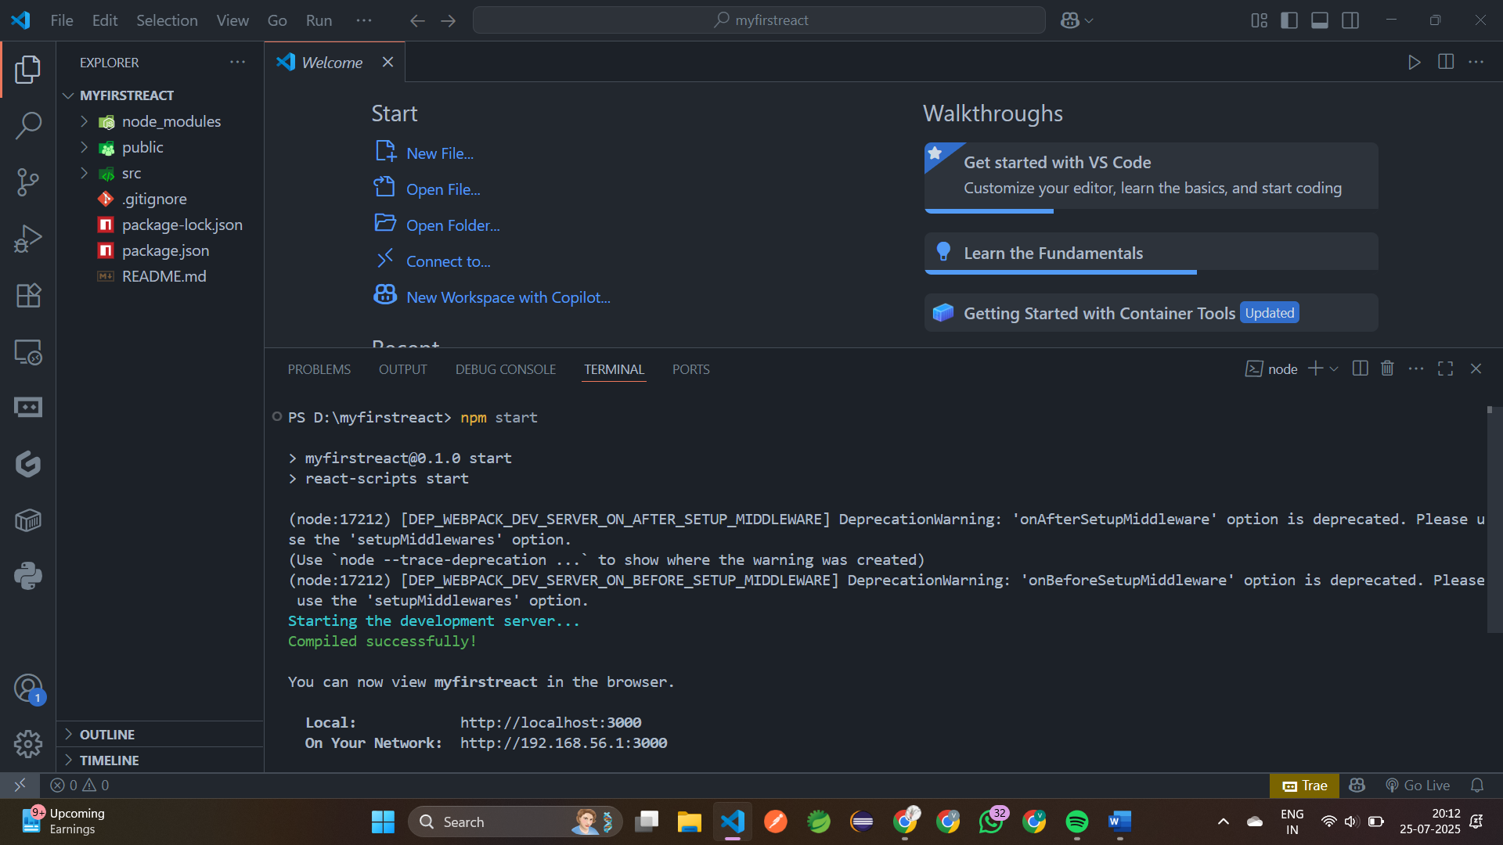

step 5: Output  
  
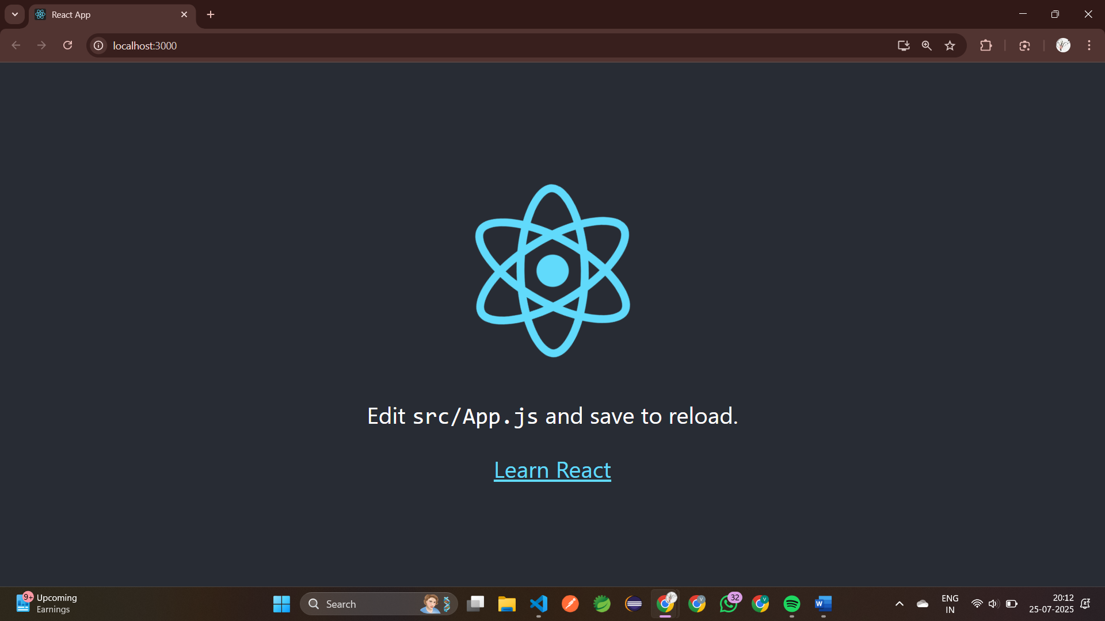

step 6: Open **App.js** in src folder of myfirstreact and replace it to print the following   
 **Welcome to the first session of React**!

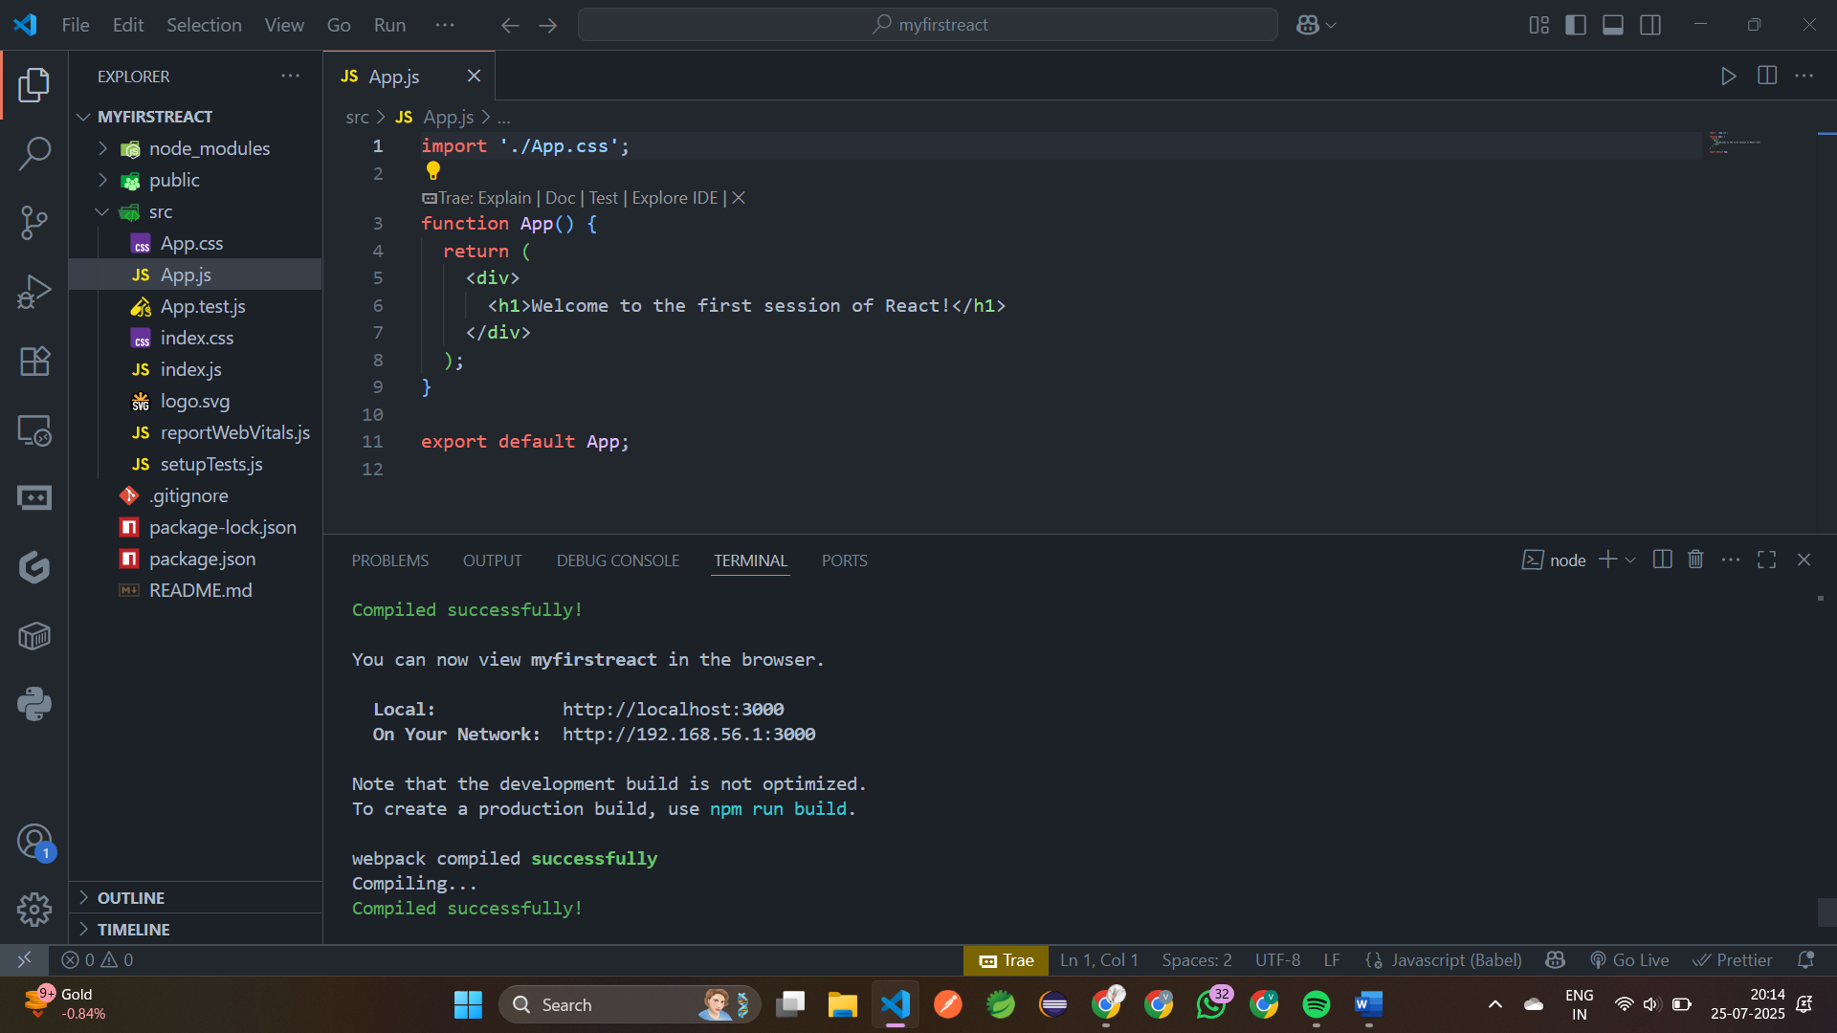

step 7: Run the app using **npm start**

step 8: Open in browser

Url: <http://localhost:3000>

**Output:**

